Frontend Development with React.js Project Documentation for Cook Book

1. **Introduction**
   * **Project Title**: Cook Book
   * **Team Members**:

 **GNANALAKSHMI C** (**Team Leader**) [Email Id: gnanalakshmi2005@gmail.com ]

  **POOJA R** [Email Id: poojajessel@gmail.com]

  **NADHIYA S** [Email Id: nadhiyasiva2004@gmail.com]

  **GIRIDHAR C** [[Email Id:](mailto:[Email%20Id:%20)  giridhar20122004@gmail.com]

  **KEERTHANA K** [Email Id: abikeerthana59@gmail.com]

1. **Project Overview**
   * **Purpose**:

Cook Book is a React-based web application designed to help users discover, organize, and create recipes easily.

* + **Goals**:

Provide a seamless, user-friendly experience with features like recipe search, categorization, and integration with external APIs**.**

1. **Architecture**
   * **Component Structure:**
     + **Components/ - Stores UI components like buttons, search bars, and recipe cards.**
     + **Pages/ - Includes different pages like Home, Categories, and Recipe Details.**
     + **Styles/ - Contains CSS files for styling.**
   * **State Management:**
     + **Uses use State and use Effect for local state handling.**
     + **API data is fetched using Axios and stored in state.**
   * **Routing:**
   * **React Router Dom is used for navigation.**
   * **Routes include:**
   * **/ - Homepage**
   * **/category/:id - Displays recipes from a selected category.**
   * **/recipe/:id - Shows recipe details.**
2. **Setup Instructions**
   * **Prerequisites**:

Node.js and npm React.js

Basic HTML, CSS, JavaScript knowledge

* + - Installation Steps:

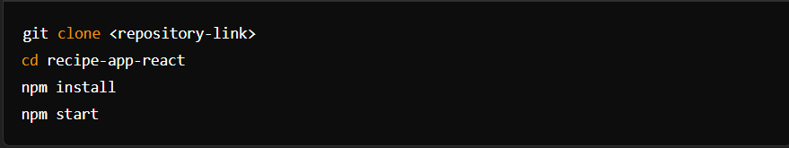

1. **Folder Structure**

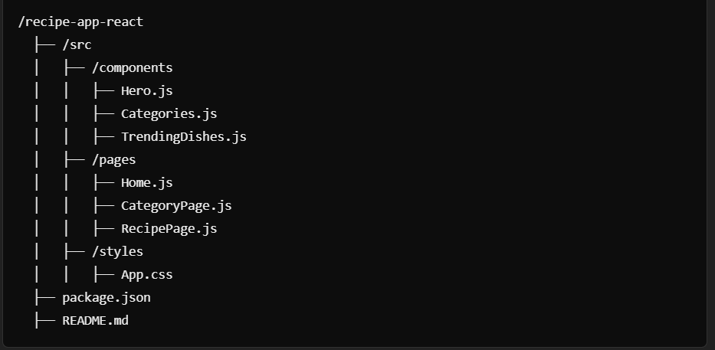

1. **Runnig the Application**

Frontend:

* + To start the frontend server, run the following command in the client directory: npm start
  + npm install
  + npx json-server ./db/db.json
  + npm run dev
  + The application will be available at [http://localhost:3000](http://localhost:3000/)

1. Component Documentation
   * **Key Components:**

Hero.js – Displays introduction and CTA. Categories.js – Shows recipe categories. TrendingDishes.js – Lists popular recipes.

* + **Reusable Components:**

RecipeCard.js – Displays individual recipes. Navbar.js – Navigation bar for the app.

1. **State Management** **Global State:**
   * State is managed locally in components using useState and useEffect.

Local State:

* + Recipe details and categories are fetched and stored in component state.

1. **User Interface**
   * **Screenshots**

Home Page:

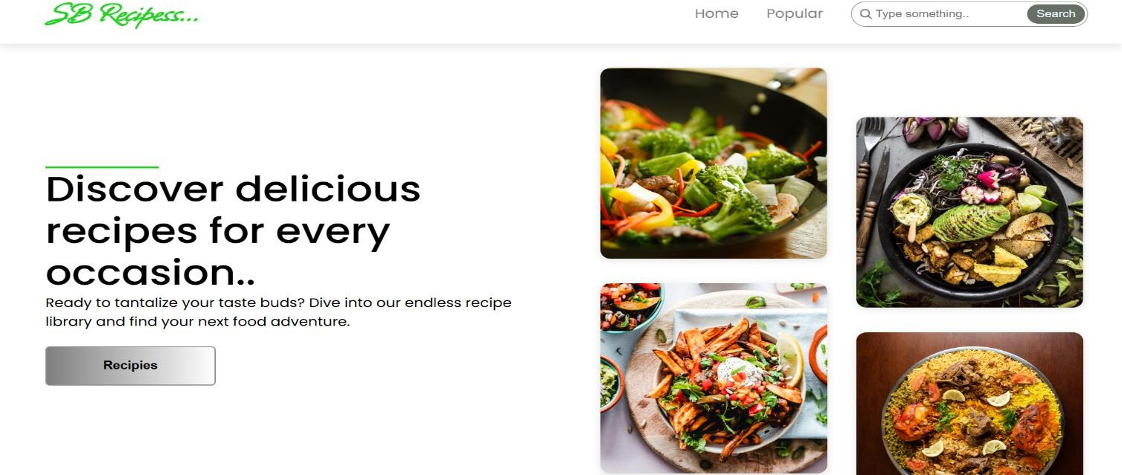

* + **Recipes Page:** Allows users to search for songs, albums, and artists.

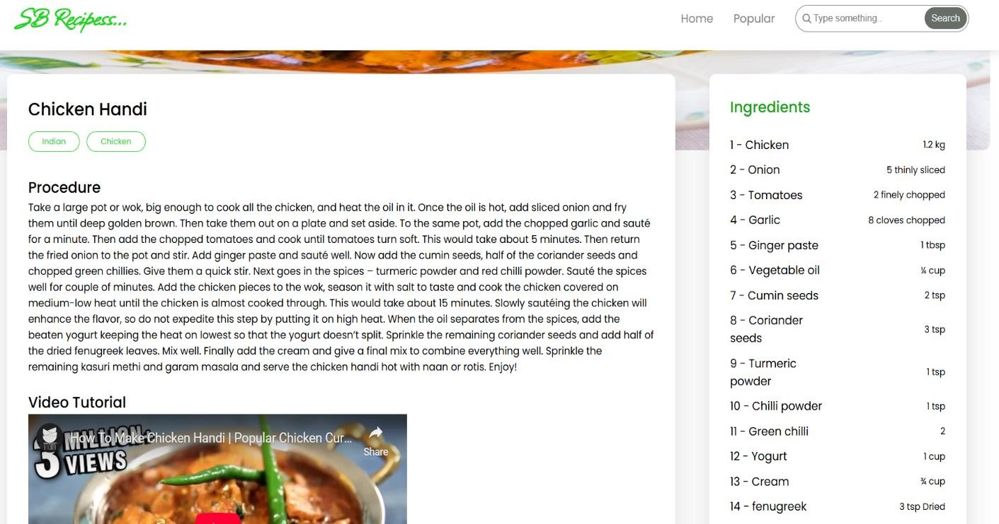

1. **Styling**
   * **CSS Frameworks/Libraries:** Bootstrap or Tailwind CSS for styling. React Icons for UI enhancements.
2. **Testing**
   * **Testing Strategy:**

Jest and React Testing Library can be used for component testing. Cypress for end-to-end testing.

* + **Code Coverage:**

Can be tracked using Jest.

1. **Screenshots or Demo Demo Link:**

https://github.com/nadhiyasiva/Cook-book/blob/main/demo-with-audio-file-made-with-clipchamp-hscpz8de-rsth3num_HLOifrgt.mp4

**Screenshots:** See section 9 for UI screenshots.

1. Known Issues
   * **Issue 1:** API rate limits may affect real-time data fetching.
   * **Issue 2:** UI responsiveness may need improvement.
2. **Future Enhancements**
   * Add user authentication for saving personal recipes.
   * Implement dark mode for better UI customization.

The Documentation Provides a Comprehensive Overview of the Cook Book Project, including its Architecture, setup instructions, and future Plans